"Do you have cough, cold, flu or sore throat symptoms?"

"Has the patient AND support person(s) had 1 or 2 COVID Vaccinations?"

(Including <12yo)
AND
"Will the patient AND support person(s) wear a mask for the appt?"

YES

NO "ASYMPTOMATIC"

NO

YES "SYMPTOMATIC"

RED STREAM

Book VIRTUAL:
Nurse Triage Pod
OR

Urgent Care/RTI Doc

Have you/patient been in a Location of Interest, a border/port worker or been
in an area with recent outbreak? YES

NO

GREEN STREAM

"Would you like a

AMBER STREAM

"Would you like a VIRTUAL appt?"

NO

"Do you need an appt today?"

YES

YES

Book VIRTUAL

Book Pod Triage or Urgent Care

"The doctor or nurse will call you and arrange for you to be seen in person if needed."

Phone pt for virtual first
See in tent, car or RTI room with increased ventilation
Pt in mask and clinician in FULL PPE(N95)
Strict hand hygiene
Limit patient contact to <15min

virtual appt?"

NO

YES

Book VIRTUAL
NO

Book F2F
Decontaminate room between each use Pt Text RTI Mobile on arrival: 0273746086

"Do you need an appt today?"

NO

Book F2F

YES

Book Pod Triage or Urgent Care

"Please park in the AMBER/RED parking around the back, the GP/Nurse will call and talk to you first then bring you in after that."
If they don't have a phone ask them to wait in their car in AMBER/RED parking and they will be collected for appt.

Phone patient for history first

*Please mark all appts as "GREEN", "AMBER" or "RED"
in 'note' when booking.

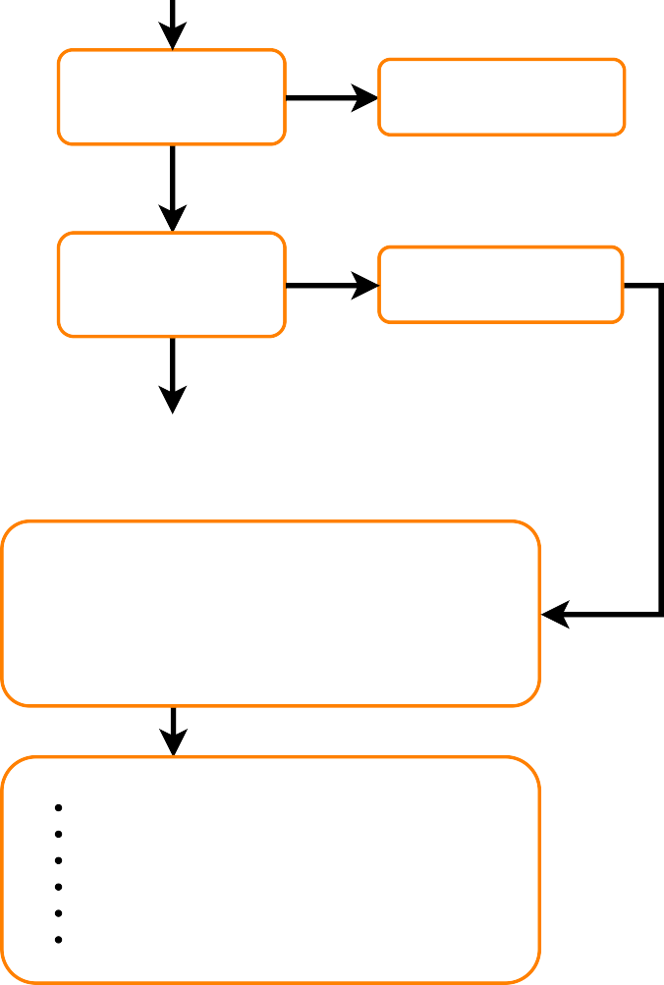"Please wear a mask and let us know if you develop cough, cold, flu, sore throat symptoms in the meantime so we can see you in a safe way"
Meet patient at door & sanitise hands Pt in mask and clinician surgical mask Strict hand hygiene
Limit patient contact to <15min
Room with increase ventilation if available

