Video consults using Doxy.me
Video consultations allow your GP to see and speak to you
When your appointment has been booked your GP will send you a link to their virtual waiting room.
Near the time of their appointment you will need to go to www.doxy.me, which will take you to this welcome page.
Click on get started and I’m a patient.
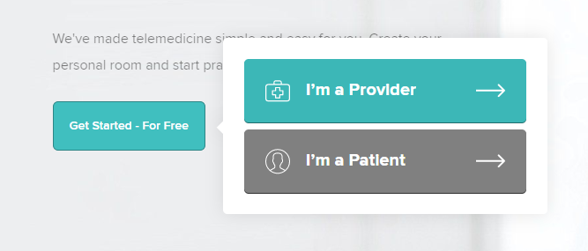
Enter the link you have been sent by your GP and click check in.
This will take you to the GP virtual waiting room.
The GP will know you are there and connect to you call as soon as they can.

